Case Study: 7
Title: To generate a registration form using html,css, js with showing the live errors for filling the credentials.
Software/Tools Required: VSC, HTML, CSS, JavaScript
Case Study program code:
index.html:
<!DOCTYPE html>
<html lang="en">
<head>
<meta charset="UTF-8">
<meta name="viewport" content="width=device-width, initial-scale=1.0">
<title>Registration Form</title>
<link rel="stylesheet" href="style.css">
</head>
<body>

<div class="container">

<div class="heading">
<span class="tag">JavaScript Practical</span>
<h1>Registration Form</h1>
<p class="subtitle">Event Handling &amp; Live Form Validation</p>
</div>

<form id="registrationForm" novalidate>

<!-- Name fields -->
<div class="row-two">
<div class="form-group">
<label for="firstName">First Name</label>
<input type="text" id="firstName" placeholder="Enter first name" autocomplete="off">
<span class="error" id="firstNameError"></span>
</div>

<div class="form-group">
<label for="lastName">Last Name</label>
<input type="text" id="lastName" placeholder="Enter last name" autocomplete="off">
<span class="error" id="lastNameError"></span>
</div>
</div>

<!-- Email -->
<div class="form-group">
<label for="email">Email</label>
<input type="email" id="email" placeholder="name@example.com" autocomplete="off">
<span class="error" id="emailError"></span>
</div>

<!-- Birthday -->
<div class="form-group">
<label for="birthday">Birthday</label>
<input type="date" id="birthday">
<span class="error" id="birthdayError"></span>
</div>

<!-- Password -->
<div class="form-group">
<label for="password">Password</label>
<input type="password" id="password" placeholder="Enter password">
<div class="strength" id="strength">
<div class="strength-bar"><span id="strengthFill"></span></div>
<small id="strengthText"></small>
</div>
<span class="error" id="passwordError"></span>
</div>

<!-- Re-enter Password -->
<div class="form-group">
<label for="confirmPassword">Re-enter Password</label>
<input type="password" id="confirmPassword" placeholder="Re-enter password">
<span class="error" id="confirmPasswordError"></span>
</div>

<!-- Terms -->
<div class="terms">
<input type="checkbox" id="terms">
<label for="terms">I agree to the Terms and Conditions</label>
</div>
<span class="error" id="termsError"></span>

<!-- Submit -->
<button type="submit">Register</button>

<div id="successMessage" class="success"></div>

</form>

</div>

<script src="script.js"></script>
</body>
</html>
Script.js:
// ---------- Accessing form elements ----------
const form = document.getElementById("registrationForm");

const firstName = document.getElementById("firstName");
const lastName = document.getElementById("lastName");
const email = document.getElementById("email");
const birthday = document.getElementById("birthday");
const password = document.getElementById("password");
const confirmPassword = document.getElementById("confirmPassword");
const terms = document.getElementById("terms");

const successMessage = document.getElementById("successMessage");
const strengthBox = document.getElementById("strength");
const strengthFill = document.getElementById("strengthFill");
const strengthText = document.getElementById("strengthText");

// Birthday cannot be a future date
birthday.max = new Date().toISOString().split("T")[0];

// ---------- Validation rules ----------
// Each function returns an error message, or "" when the value is valid.

const namePattern = /^[A-Za-z][A-Za-z' -]*$/;
const emailPattern = /^[^\s@]+@[^\s@]+\.[^\s@]{2,}$/;

function checkName(value, label) {
value = value.trim();
if (value === "") return `${label} is required.`;
if (value.length < 2) return `${label} must have at least 2 letters.`;
if (!namePattern.test(value)) return `${label} can contain letters only.`;
return "";
}

function checkEmail() {
const value = email.value.trim();
if (value === "") return "Email is required.";
if (!emailPattern.test(value)) return "Enter a valid email address.";
return "";
}

function checkBirthday() {
if (birthday.value === "") return "Birthday is required.";

const born = new Date(birthday.value);
const today = new Date();
if (born > today) return "Birthday cannot be in the future.";

let age = today.getFullYear() - born.getFullYear();
const hadBirthday =
today.getMonth() > born.getMonth() ||
(today.getMonth() === born.getMonth() && today.getDate() >= born.getDate());
if (!hadBirthday) age--;

if (age < 13) return "You must be at least 13 years old.";
return "";
}

function checkPassword() {
const value = password.value;
if (value === "") return "Password is required.";
if (value.length < 6) return "Password must contain at least 6 characters.";
if (!/[A-Za-z]/.test(value) || !/\d/.test(value)) {
return "Password must include a letter and a number.";
}
return "";
}

function checkConfirmPassword() {
if (confirmPassword.value === "") return "Please re-enter your password.";
if (confirmPassword.value !== password.value) return "Passwords do not match.";
return "";
}

function checkTerms() {
return terms.checked ? "" : "You must agree to the Terms and Conditions.";
}

// ---------- Field list: input + error box + rule ----------
const fields = [
{ input: firstName, error: "firstNameError", rule: () => checkName(firstName.value, "First name") },
{ input: lastName, error: "lastNameError", rule: () => checkName(lastName.value, "Last name") },
{ input: email, error: "emailError", rule: checkEmail },
{ input: birthday, error: "birthdayError", rule: checkBirthday },
{ input: password, error: "passwordError", rule: checkPassword },
{ input: confirmPassword, error: "confirmPasswordError", rule: checkConfirmPassword },
{ input: terms, error: "termsError", rule: checkTerms }
];

// Runs a field's rule and shows (or clears) its error message
function validateField(field) {
const message = field.rule();
document.getElementById(field.error).textContent = message;

if (field.input.type !== "checkbox") {
field.input.classList.toggle("invalid", message !== "");
field.input.classList.toggle("valid", message === "");
}
return message === "";
}

// ---------- Password strength meter ----------
function updateStrength() {
const value = password.value;

if (value === "") {
strengthBox.style.display = "none";
return;
}

let score = 0;
if (value.length >= 6) score++;
if (value.length >= 10) score++;
if (/[a-z]/.test(value) && /[A-Z]/.test(value)) score++;
if (/\d/.test(value)) score++;
if (/[^A-Za-z0-9]/.test(value)) score++;

const levels = [
{ text: "Weak", color: "#dc2626", width: "33%" },
{ text: "Medium", color: "#f59e0b", width: "66%" },
{ text: "Strong", color: "#16a34a", width: "100%" }
];
const level = score <= 2 ? levels[0] : score <= 3 ? levels[1] : levels[2];

strengthBox.style.display = "block";
strengthFill.style.width = level.width;
strengthFill.style.background = level.color;
strengthText.textContent = "Strength: " + level.text;
strengthText.style.color = level.color;
}

// ---------- Events ----------
fields.forEach(function (field) {
const input = field.input;

// FOCUS event: highlight the active field's label
input.addEventListener("focus", function () {
const label = document.querySelector(`label[for="${input.id}"]`);
if (label) label.classList.add("active");
});

// BLUR event: remove highlight and validate when the user leaves
input.addEventListener("blur", function () {
const label = document.querySelector(`label[for="${input.id}"]`);
if (label) label.classList.remove("active");
validateField(field);
});

// INPUT event: live validation while the user types
input.addEventListener(input.type === "checkbox" ? "change" : "input", function () {
successMessage.textContent = "";
validateField(field);
});
});

// Password changed: refresh the meter and re-check the confirm box
password.addEventListener("input", function () {
updateStrength();
if (confirmPassword.value !== "") {
validateField(fields[5]);
}
});

// ---------- SUBMIT event ----------
form.addEventListener("submit", function (event) {
// Stop the page from refreshing
event.preventDefault();

// Validate every field (don't stop at the first error)
const results = fields.map(validateField);
const allValid = results.every(Boolean);

if (!allValid) {
successMessage.textContent = "";
const firstBad = fields.find((f, i) => !results[i]);
firstBad.input.focus();
return;
}

successMessage.textContent =
`Registration successful! Welcome, ${firstName.value.trim()}.`;

// Show the entered data in the console (password is never logged)
console.log("First Name:", firstName.value.trim());
console.log("Last Name:", lastName.value.trim());
console.log("Email:", email.value.trim());
console.log("Birthday:", birthday.value);

// Reset the form and clear the validation styles
form.reset();
strengthBox.style.display = "none";
fields.forEach(function (f) {
f.input.classList.remove("valid", "invalid");
});
});
Style.css:
* {
box-sizing: border-box;
margin: 0;
padding: 0;
}

body {
font-family: Arial, Helvetica, sans-serif;
background: linear-gradient(160deg, #eef2ff, #e0e7ff);
color: #1f2937;
min-height: 100vh;
display: flex;
justify-content: center;
align-items: center;
padding: 30px;
}

.container {
background-color: white;
width: 100%;
max-width: 560px;
padding: 32px;
border-radius: 16px;
border-top: 5px solid #4f46e5;
box-shadow: 0 10px 30px rgba(49, 46, 129, 0.15);
}

.heading {
text-align: center;
margin-bottom: 24px;
}

.tag {
display: inline-block;
font-size: 11px;
font-weight: bold;
letter-spacing: 1.5px;
text-transform: uppercase;
color: #4f46e5;
background-color: #eef2ff;
padding: 5px 12px;
border-radius: 999px;
margin-bottom: 10px;
}

h1 {
font-size: 28px;
margin-bottom: 6px;
}

.subtitle {
color: #6b7280;
font-size: 14px;
}

.row-two {
display: grid;
grid-template-columns: 1fr 1fr;
gap: 0 16px;
}

.form-group {
margin-bottom: 14px;
}

label {
display: block;
margin-bottom: 6px;
font-size: 14px;
font-weight: bold;
transition: color 0.2s;
}

label.active {
color: #4f46e5;
}

input[type="text"],
input[type="email"],
input[type="date"],
input[type="password"] {
width: 100%;
padding: 11px 12px;
border: 2px solid #d1d5db;
border-radius: 8px;
font-size: 15px;
font-family: inherit;
background-color: #fafafa;
transition: border-color 0.2s, background-color 0.2s;
}

input:focus {
outline: none;
border-color: #4f46e5;
background-color: white;
}

input.valid {
border-color: #16a34a;
}

input.invalid {
border-color: #dc2626;
}

.strength {
display: none;
margin-top: 8px;
}

.strength-bar {
height: 6px;
background-color: #e5e7eb;
border-radius: 999px;
overflow: hidden;
}

.strength-bar span {
display: block;
height: 100%;
width: 0;
transition: width 0.25s, background 0.25s;
}

.strength small {
display: block;
margin-top: 4px;
font-size: 12px;
font-weight: bold;
}

.terms {
display: flex;
align-items: center;
gap: 8px;
margin-top: 6px;
}

.terms label {
margin: 0;
font-weight: normal;
}

.error {
display: block;
color: #dc2626;
font-size: 13px;
margin-top: 5px;
min-height: 17px;
}

.success {
color: #15803d;
text-align: center;
font-weight: bold;
margin-top: 16px;
}

button {
width: 100%;
padding: 13px;
margin-top: 14px;
border: none;
border-radius: 8px;
background-color: #4f46e5;
color: white;
font-size: 16px;
font-weight: bold;
cursor: pointer;
transition: background-color 0.2s;
}

button:hover {
background-color: #4338ca;
}

@media (max-width: 520px) {
.row-two {
grid-template-columns: 1fr;
}
}
Output:
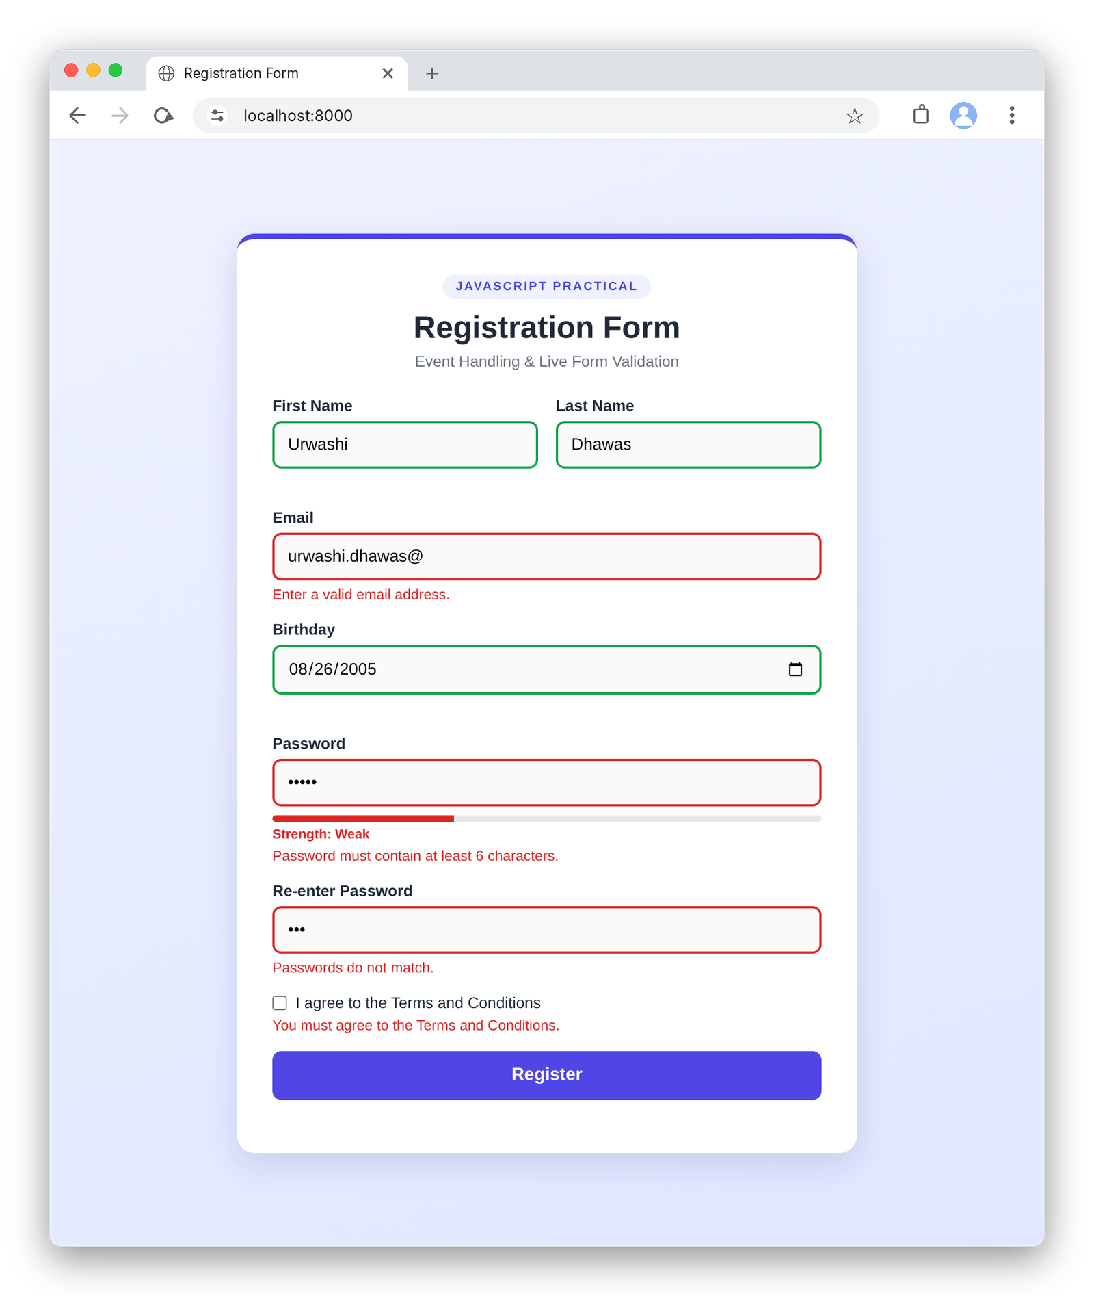

RESULT
The experiment was successfully performed and the registration form using html, css and js was implemented showing live errors.

